**What are the origins of the Palestinian national movement?**

**Lesson 3**

*Falastin*: a national Palestinian newspaper established in 1911

**By the end of this lesson, you should be able to:**

Define nationalism

Explain the emergence of Palestinian nationalism

Compare the contradictory promises made by Britain during the First World War

**Keywords**

Nationalism

Arabs

Sykes-Picot Agreement, 1916

Hussein-McMahon Correspondence, 1916

Balfour Declaration, November 1917

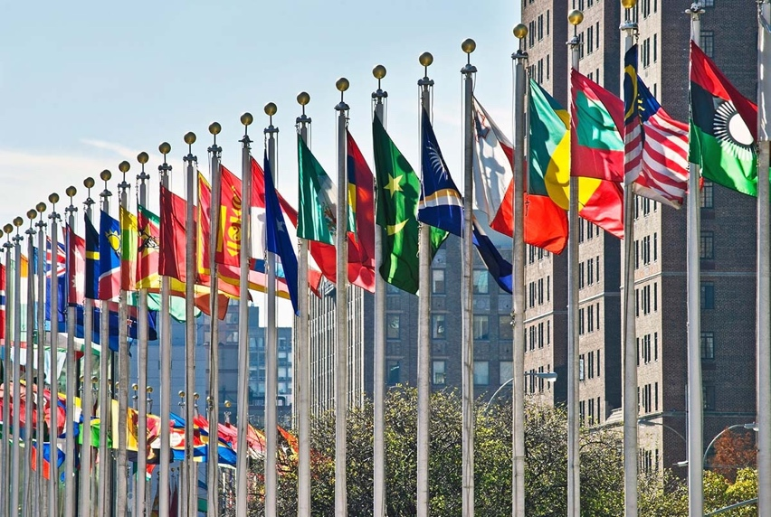

**Knowledge check!**

1)What is nationalism?

2)What is the difference between a country and a nation?

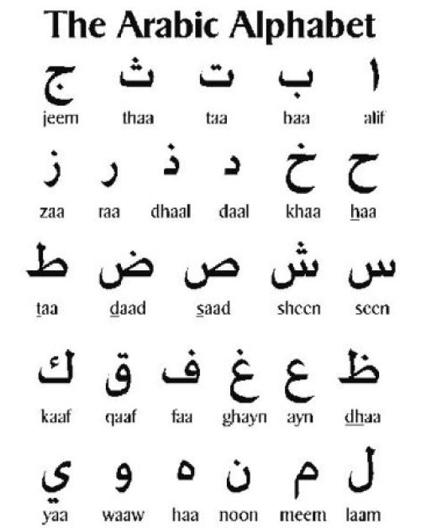

**Knowledge check!**

1)Where is Arabic spoken?

2)What is the difference between Muslim identity and Arab identity?

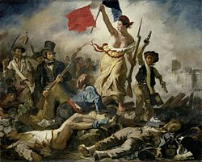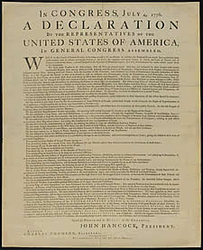

***Nationalism:*** *the belief that one's country or state is distinct from and superior to others, and that it should govern itself*

**Nationalism**

Nationalism emerged in Britain during the Industrial Revolution, as people began to identify less with their immediate family or town, and more with the country as a whole**.** National flags and other symbols were introduced during this period, including the Union Jack in 1801

Similar ideas developed in America at this time, contributing to American opposition to unrepresentative British rule. One of the earliest examples of nationalism is the American Declaration of Independence from British rule in 1776. Not long after this there was the French Revolution of 1789, when people in France demanded to be ruled by a fairer, more representative government. These ideas also spread to Germany and Italy, who both formally unified as nations in 1871

It was in this context of nationalism that the Jewish national movement of Zionism emerged in the nineteenth century, as we saw in Lesson 2

**Question**

Can you describe Zionism in one sentence?You can use your notes from Lesson 2 to help you

**Activity**

Write a short paragraph explaining the emergence of nationalism in the nineteenth century. Provide at least one example

**Arab and Palestinian nationalism**

Arab nationalism first emerged among Arab intellectuals as a response to dissatisfaction with the rule of the Ottoman Empire in the 1800s. This was the idea that Arabs are bound together by **ethnicity, language and culture**. Arab nationalism became increasingly popular in the early 1900s, with the Young Arab Society established in 1911. Arab nationalists sought an independent Arab state, free from Ottoman rule

Then, in the early 1900s, partly due to the threat of Zionism, **Palestinian nationalism** emerged. Palestinian nationalists broke away from Arab nationalists and sought an **independent Palestinian state**

**Activity**

Can you fill in the blanks using the words and dates provided?

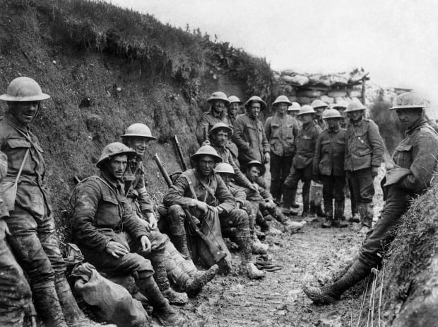

**World War One**

Key Information

**Start:** July 1914

**End:** November 1918

**Trigger cause:** assassination of Archduke Franz Ferdinand of Austria

**Allied powers:** Britain, France, USA, Russia, Italy, Japan, Romania

**Central powers:** Germany, Austria-Hungary, Ottoman Empire, Bulgaria

Nationalism

Nationalism led to **high tensions** between countries before the outbreak of war, making war **more likely.** It also led countries to build up their armies, increasing their **militarism** (their ability to wage war). Nationalism additionally meant that more people signed up to **fight for their country**

The Ottoman Empire

The Ottoman Empire joined on the side of the Central powers in October 1914. When the Central powers lost the war, there was no one to govern the territories of the Ottoman Empire (including Palestine-Israel). During the war, Britain had made **conflicting promises** to both the Jews and the Palestinians about what would happen to Palestine-Israel after the war…

**A)Sykes-Picot Agreement, 1916:**

An agreement between Britain and France to divide the territories of the Ottoman Empire between them after the war, with Britain getting Palestine-Israel

**B)Hussein-McMahon Correspondence, 1916:**

The British Government promised the Arabs that if they revolted against the Ottoman Empire, Britain would recognise an independent Arab state after the war

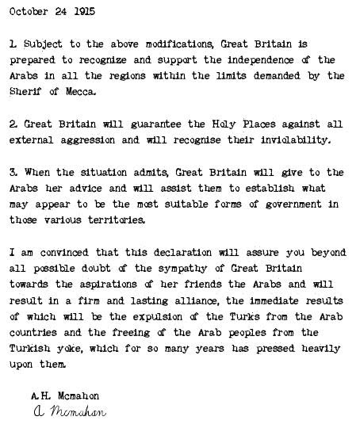

**C)Balfour Declaration, November 1917:**

Promised the British Government’s support for a ‘national home’ for the Jews in Palestine-Israel

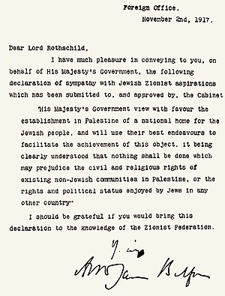

**Activity**

Read through promises A, B and C and answer these questions:

What was Arab nationalism? What are the consequences of promise B for Arab nationalism?

What was Zionism? What was being promised to the Jews in promise C? How would this make the Palestinians feel?

Can you identify any contradictions between these promises?

Extension question: Were these promises clear, or could they be misinterpreted?

**Extension activity**

Make a table explaining how you would feel about each promise if you were Jewish or Palestinian:

**Check your knowledge!**

What are some key examples of nationalist movements?

When and why did Palestinian nationalism develop?

What promises did Britain make to the Jews and the Palestinians during WWI? Why were these problematic?